HOMECOMING 2025 SPIRIT WEEK!!

Sep 29-Oct 3, 2025

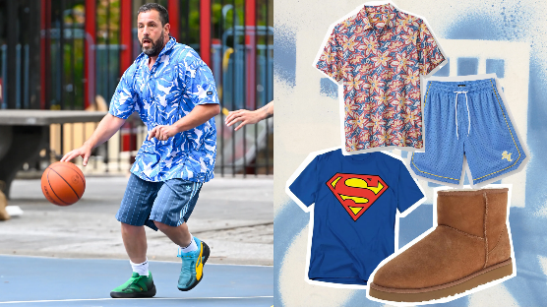Monday: Adam Sandler Day

Please choose any of his movie characters, including Happy Gilmore, Bobby Boucher, or Sonny Koufax, and emulate his distinctive style by wearing casual, comfortable attire often featuring baggy shorts, sneakers, and t-shirts. Look for that relaxed, layered look that includes a baggy T-shirt, Basketball Shorts, or Baggy sweats paired with sneakers with a backward-worn baseball cap.

*No short Nike shorts, spandex, mid-rift, or flip flops allowed.*

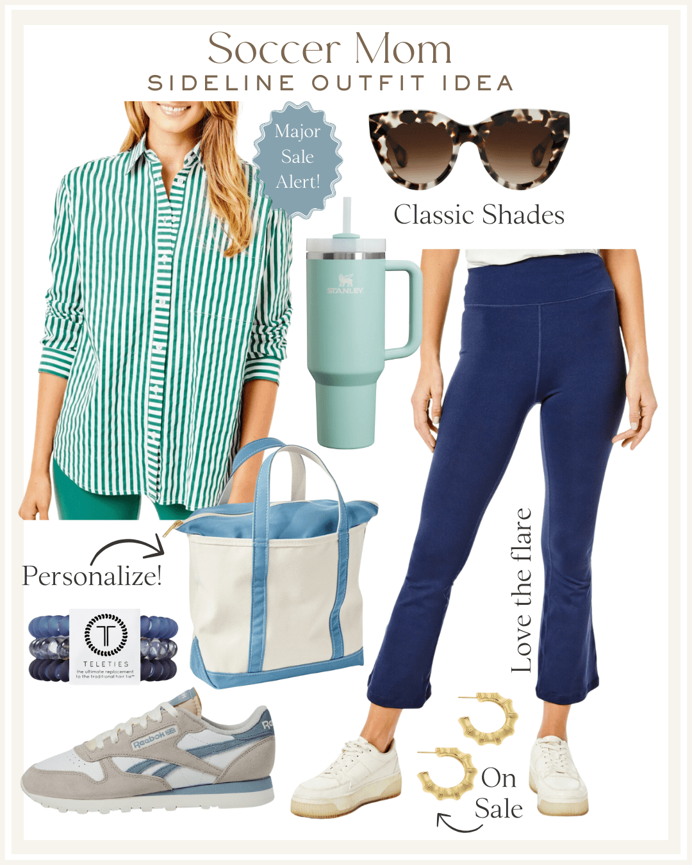Tuesday: Soccer Mom vs. BBQ Dad

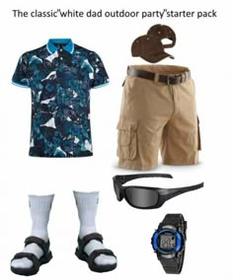Today, dress like a Soccer Mom or a BBQ Dad.

Soccer moms should opt for athleisure or comfortable, casual clothing, such as athletic shorts, a comfortable t-shirt, a hat or visor, sunglasses, and sneakers, accompanied by a practical tote bag containing snacks, water, and other essentials.

*No short Nike shorts, spandex, mid-rift, or flip flops allowed.*

BBQ Dads: Dress up like Dads who take pride in their BBQ. Comfortable pants, jeans, or cargo shorts with a Hawaiian or casual shirt with an apron. Grilling tools like a spatula and tongs accent the outfit nicely, nothing sharp allowed.

*No gym wear allowed.*

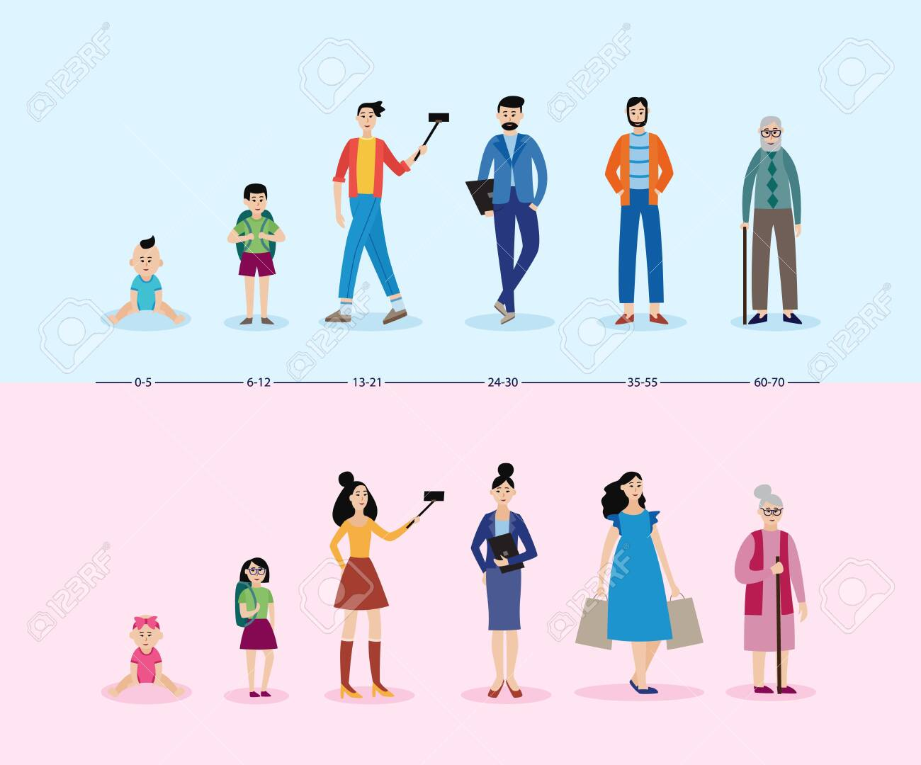Wednesday: Stages of life

**Seniors-** are asked to dress like senior citizens, think old-fashioned but comfortable clothing, including sweaters, shawls, suspenders, button-down shirts, cardigans, suits, pajamas &, slippers, pearl necklaces, grey

hair, reading glasses, a cane, etc..

*Please be respectful. No Gym wear allowed.*

**Juniors and Adults:** Dress in career day attire, such as a construction worker, chef, Homemaker, Business owner, Accountant, Lawyer, or artist.

*No Gym wear, short Nike shorts, spandex, mid-rift, or flip flops allowed.*

**Sophomores**: Dress like a teenager, wear comfortable, baggy clothes, including jeans, sweats or gym shorts, t-shirt, sneakers, hoodie, etc Gym wear allowed.

*No short Nike shorts, spandex, mid-rift, or flip flops allowed.*

**Freshmen: Dress up as if in grade school:** graphic t-shirts, princesses, fun hairstyles. Outfits you would wear when you were younger. No short Nike shorts, spandex. Or flip flops allowed.

**JH students can dress up like Toddlers:** Think clothes with cartoon characters, Dora, Mickey Mouse, Peppa Pig, SpongeBob, Paw Patrol, etc., or pajamas, baby bonnet, pacifier, baby bottle, slippers, etc. No short Nike skirts, spandex, or flo

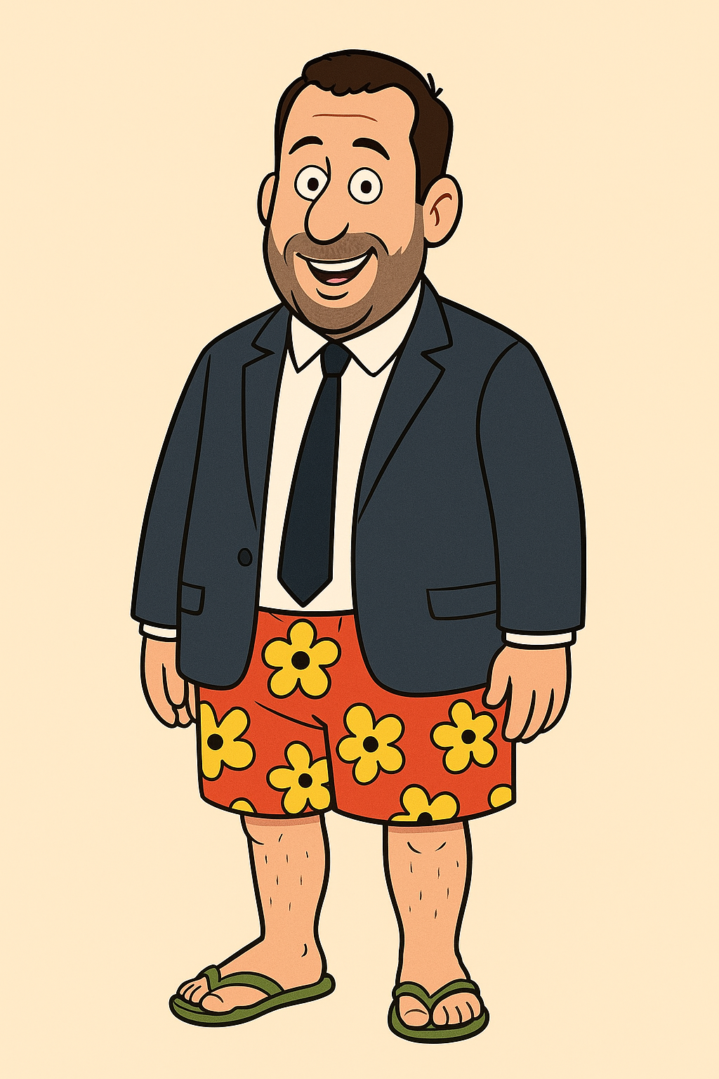Thursday: Business on top, Party on bottom

Students can wear formal or promotional clothing on their upper half, festive or relaxed clothing on the bottom. The top half should wear a suit jacket, a button-down shirt, a tie, and an appropriate business blouse. On the bottom, wear jeans, Basketball shorts, sweats, etc. Comfortable tennis shoes to wrap it all up.

*No short Nike shorts, spandex, mid-rift, or flip flops allowed*.

Friday: Blue and **Gold**

Wear our school colors to show your school spirit. All clothing must be in good shape. No rips, tears or holes. No gym wear.

*No gym wear, tank tops, midriff, and open-toed shoes and no tears in jeans.*

**REMINDER: you will be going to church in this outfit. Be presentable for the Lord.**

|  |
| --- |
| **RESTRICTIONS / GUIDELINES FOR ALL DAYS**:  All high school students are encouraged to **participate** in **SPIRIT WEEK** activities; however, students not dressed in the theme of the day will need to be in a regular school uniform. All attire is subject to administrative approval, the guidelines of the student handbook and those stated above.  Unless otherwise stated, there should be:   * No gym wear or flip flops will be allowed on any of the days throughout the week. * No cutoffs or clothing with holes. Shorts or skirts must abide by the school rules for length.   We ask that all these outfits be modest and to remember you are representing the school.  **Make the most out of this spirit week.** |