Shady Spring
High School
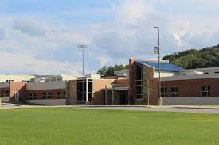

Parent & Student Handbook
2025-2026

Table of Contents
Welcome and School Overview 4
Message from the Principal—Kari Vicars 4
2025-2026 SSHS Staff Directory 5
Mission Statement 6
Bell Schedule 7
Academic Information 8
Guidance and Counseling 8
Ranking of Students and Grading System 9
Secondary School Promotion Policy 9
Honors Course Enrollment Requirement for Freshmen 10
Mid-term Reports and Semester Exams 10
Exam Exemption Policy 10
Make Up/Missing Work Policy: 11
Attendance Requirements 11
Attendance Procedures: 11
Tardy Policy: 12
Early Dismissals and Bus Notes 12
Early Dismissal Procedure: 12
Deliveries to Students During the School Day: 13
Early Graduation Request 13
High School Credit for College Work 13
Early College Admission Guidelines 13
Participation in Graduation Exercises 14
Honor Graduates 14
Student Behavior & Expectations 15
Safe and Supportive Schools 15
Student Cell Phone Policy: 16
Dress Code: 17
Tobacco 17
Raleigh County Expected Behavior in Safe and Supportive Schools (Policy D.3.22) 17
Behaviors/Consequences 18
SSHS Dance Policy: 24
Technology & Safety 24
School Crisis Plan 24
Internet and Computer Networks Policy 24
Illness-Injury 25
Medication Policy 25
Pest Control 25
Student Life 26
Driving and Parking Regulations 26
School Lunch Program: 27
Clubs and Organizations 28
Athletic Eligibility: 29
Parent & Student Rights 30
Parental Grievance Forms 30
Access to Educational Records 30

Welcome and School Overview

Message from the Principal—Kari Vicars

Welcome Back Tigers!
I am so excited to welcome you all to Shady Spring High School for the 2025-2026 school year.
We look forward to a year of continued academic achievement and growth.
This handbook provides essential information and outlines the expectations we have at Shady Spring High School for both students and their parents/guardians. Please take the time to read it carefully.
This year, we’re continuing to focus on three key areas that help make our school a great place to learn and grow: Attend, Behave, Commit.
Showing up every day, making good choices, and giving your best effort, these are the habits that lead to success, not just in high school but in life. Whether you're aiming for graduation, college, a career, or just a strong finish to the school year, these three things will help you get there.
We want you to get everything you can out of your time here at SSHS. This is your chance to build friendships, try new things, and push yourself in academics, sports, and extracurriculars. Whether it’s joining a club, taking a challenging class, or getting involved in music or the arts, there’s something here for everyone.
Don’t be afraid to step outside your comfort zone, this is where great memories and big accomplishments begin.
I want you to know that I take great pride in being the principal of Shady Spring High School, and my main goal is to see my students happy and successful. I believe that we have a school full of future doctors, lawyers, teachers, engineers, welders, carpenters, police officers, and many other professions that are going to make a huge difference in this world. It is my privilege to get to lead some of the best and brightest minds in the state of WV.
Please let me know if I can do anything to help you along the way. I am looking forward to a great
year, and as always, it’s a great time to be a Tiger!

Sincerely,

Kari Vicars
Principal, SSHS

2025-2026 SSHS Staff Directory

Below is a listing of our staff by Department. Schoology is our preferred method of communication with our faculty. If you need information regarding setting up a Schoology account, please contact the school.
Administration:

Name | Position/Department | Extension
Kari Vicars | Principal | 5201
Scotty Pennington | Assistant Principal | 5203
Eric Lester | Assistant Principal | 5202
Ronnie Olson | Athletic Director | 5235

Front Office:

Name | Position/Department | Extension
Mitzi Richmond | Financial Secretary | 5206
Lisa Webb | Secretary | 5200
Alyssa Maynard | School Nurse | 5258

Counseling Department:
Social Studies Department:
Brandon Bennett
Corey Handy
Lisa Hinkle
Brianna Meade
Christina Meador
Carey Radford
Tim Smith

Name | Position/Department | Extension
Laura Culicerto | 12th Grade Counselor/Coordinator of Student Support Services | 5204
Chelsea Dorsey | 9th Grade Counselor, 10th grade (A-L) | 5256
Julie Holliday | 11th Grade Counselor, 10th grade (M-Z) | 5205
English Department
TBA English 1
Kristin Ayers
Brad Bostic
Allyson Boland
Martha Holt
Nikki Lester
TBA English 2

CTE
Amanda Harvey
Kelli Hatfield
Ginger Lovell
Kevin Okes
Cindy Rhudy

Special Education Department:
Heather Brown
Melissa Farley
Christina Furrow
Shawna Harvey
Shannon Lynch
Ronnie Olson
John Smith
Niko Thibeault

Name | Position
Lonnie Carper | SRO
Joey Beckett | ISS
Amanda Cooper | Library/Media Support

Science Department
Jim Cantley
Mike Evans
Elizabeth Hegele
TBA Science
Angela Killen
Timothy Paynter
J.C. Phares

Related Arts:
Norma Acord
Donald Barnett
Machelle Bum-Farley
Vince Culicerto
Phil Culicerto
Tim Fama
Cheryl Gabbert
Kenya Smith

Math Department
Michelle Cox
Samuel Gross
Elizabeth Hegele
Eric Lawson
Allyson Perez
Ashley Stevens
Bill Wood

Mission Statement
Raleigh County Schools: Making a Difference One Student at a Time
Shady Spring High School: Learners Today; Leaders Tomorrow
Shady Spring High School Core Beliefs – We Believe:
- Attend:
  - Consistency Leads to Success: Regular attendance is key to building knowledge and skills that contribute to both academic and personal growth.
- Behave:
  - Positive Behavior Builds Community: By behaving appropriately, you contribute to a safe and supportive school culture.
- Commit:
  - Follow Through Matters: Consistent commitment to your goals and responsibilities will lead to long-term success, both in school and beyond.
Notice of Nondiscrimination:
The Raleigh County Board of Education does not discriminate on the basis of race, color, national origin, sex, disability, or age in its programs and activities. The following person has been designated to handle inquiries regarding the nondiscrimination policies: Teresa Lewis, Director of Pupil Services and Title IX and Title II Officer 105 Adair Street Beckley, WV 25801 304-256-4500, ext. 3329.

Bell Schedule
BELL SCHEDULE
SHADY SPRING HIGH SCHOOL
2025-2026 SCHOOL YEAR

Time
Arrival-7:12
7:15-8:10 |  | 1st Period
8:14-8:41 |  | LINKS/Grab and Go
8:45-9:40 |  | 2nd Period
9:44-10:39 |  | 3rd Period
10:39-11:09 |  | 1st Lunch | 11:13-12:26 | 4th Period
10:43-11:17 | 11:47-12:26 | 4th Period | 11:17-11:47 | 2nd Lunch
10:43-11:56 |  | 4th Period | 11:56-12:26 | 3rd Lunch
12:30-1:25 |  | 5th Period
1:29-2:24 |  | 6th Period
2:24 |  | Drivers and Parent Pickup Dismissed
2:26 |  | 1st Bus Dismissed
Announcement |  | 2nd Bus Dismissed All Student Athletes Staying for Practice will leave on this announcement)

2 HOUR DELAY SCHEDULE

Time
Arrival to 9:11 |  | Gym/Cafeteria
9:16-9:53 |  | 1st Period
9:57-10:34 |  | 2nd Period
10:34-11:04 |  | 1st Lunch | 11:08-12:21 | 4th Period
10:38-11:12 | 11:42-12:21 | 4th Period | 11:12-11:42 | 2nd Lunch
10:38-11:51 |  | 4th Period | 11:51-12:21 | 3rd Lunch
12:25-1:02 |  | 3rd Period
1:06-1:43 |  | 5th Period
1:47-2:24 |  | 6th Period
2:24 |  | Drivers/Parent Pickup Dismissed
2:26 |  | 1st Bus Dismissed
Announcement |  | 2nd Bus Group Dismissed (All Student Athletes Staying for Practice will leave on this announcement)

Academic Information

Guidance and Counseling

The guidance and counseling staff is committed to providing services and support to students, school staff, parents, and school community to help each student achieve his or her goals. Counselors work with students individually and in groups to aid in personal, social, career, and educational development.

Throughout the school year, counselors arrange meeting times with students and/or parents to discuss academic status, graduation evaluations, and college exploration. At other times, students are encouraged to make an appointment to meet with their counselor, except in crisis situations. Appointments can be made before school, between classes if time permits, during lunch, or after school. Appointments can be arranged by calling the guidance offices. Students are responsible for securing an appointment confirmation from the counseling office and MUST have permission from the teacher before leaving the classroom.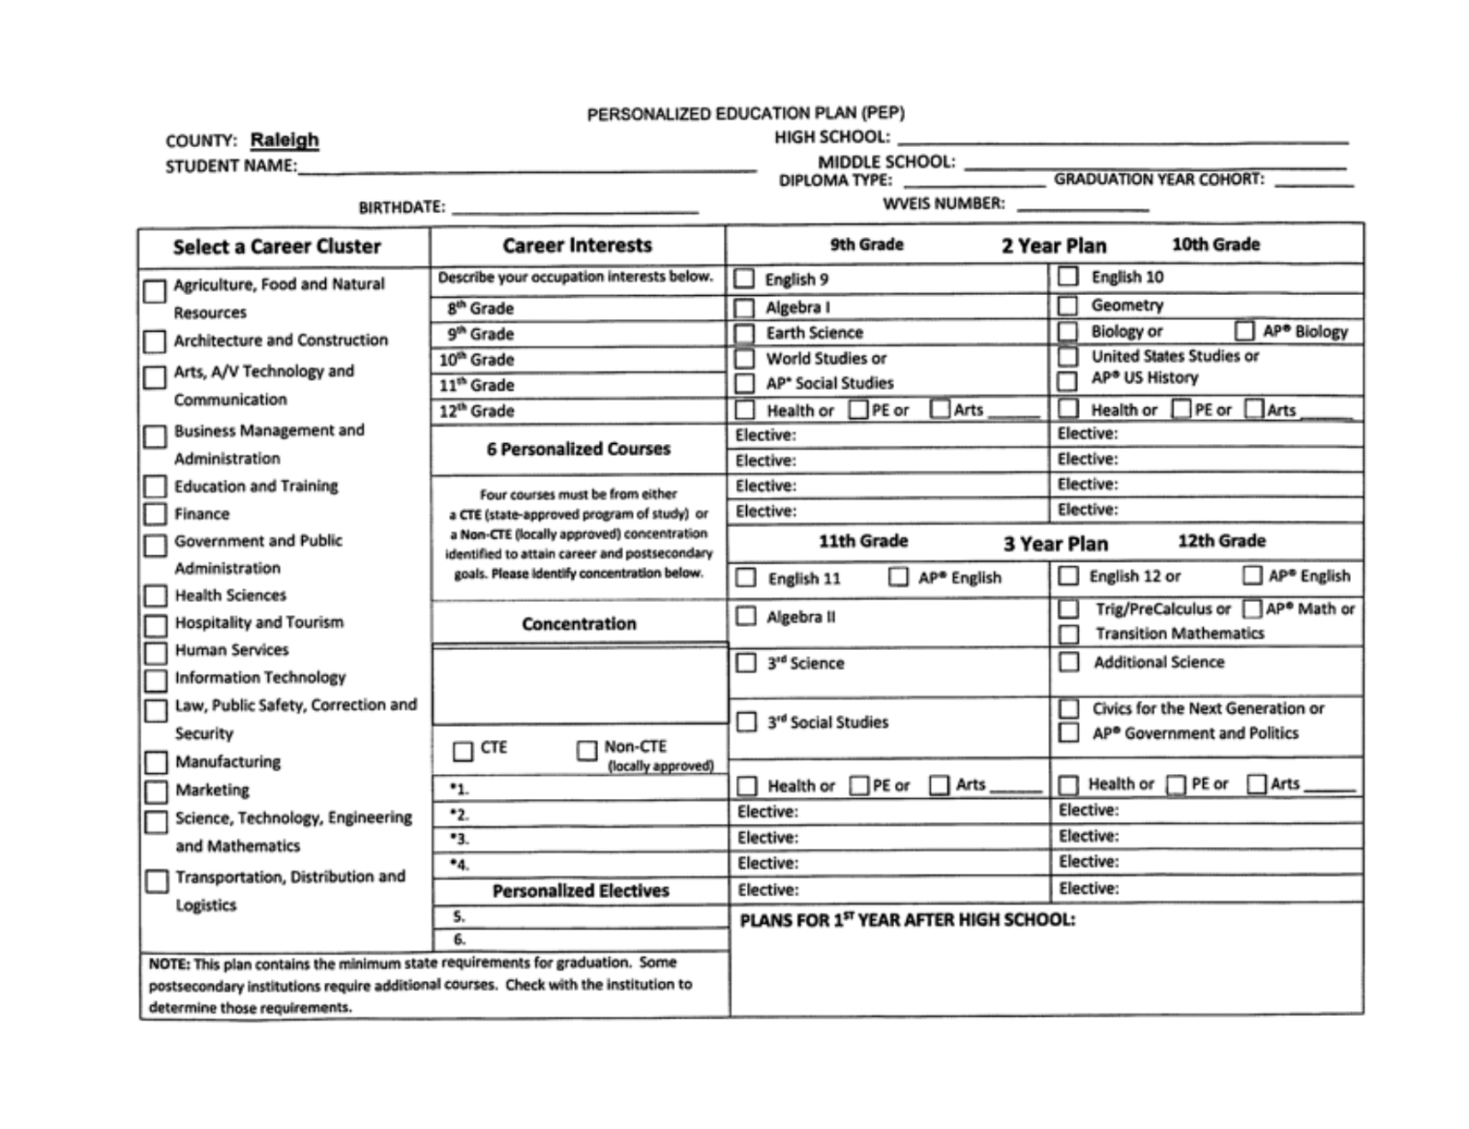

Ranking of Students and Grading System

Quality Point Computation Scale
Grade | AP Class | Honors Class | Regular Class
90-100-A | 5.0 | 4.5 | 4.0
80-89-B | 4.0 | 3.5 | 3.0
70-79-C | 3.0 | 2.5 | 2.0
60-69-D | 2.0 | 1.5 | 1.0
0-59-F | No Credit | No Credit | No Credit

The interpretation of the grading system is as follows:
- Excellent or Exceptional Progress by the Student
- Good Progress with Above Average Achievement by the Student
- Average Progress on Fair Accomplishment by the Student
- Satisfactory or Minimum Progress with Passing and Credit
- Unsatisfactory Progress or Failure with No Credit

Computation of Grades - At the end of each nine-week period, a grade card will be given to each student indicating the percent score/letter grade the student has earned that nine weeks. At the end of the term, the grade shall be computed from each nine-week letter grade and the exam will count as one-seventh (1/7) of the final grade. The letter grade will appear on the student’s transcript as the final grade for the semester, and semester/term letter grades will determine quality points and will also be used for computation for athletic eligibility. The quality point will be used for ranking and grade point average.

Reporting of Grades - A hard copy for reporting grades shall be on a nine-week basis in all schools. Electronic reporting is available at all times through Schoology. Parents can contact the school to set up their parent Schoology account.

Repeating a Class: Whenever a student repeats a course, both grades will be used when computing GPA and rank in class. Courses may be repeated only when student has earned a grade of C or lower.

Secondary School Promotion Policy

- A student in the ninth grade, in order to be considered for promotion to the tenth grade, must pass a minimum of five units of credit of 9th grade work.

- Students in high school shall be classified according to the units or credits they have accumulated. Grade-level or homeroom status will be determined by the following sequence of progress toward graduation:
Sophomore 5 Credits
Junior 11 Credits
Senior All seniors must be enrolled or have successfully completed English 12, Civics, and be within 8 credits of graduation. All seniors must be scheduled for a full instructional day unless otherwise approved under Policy D.3.1.

- Any student considering dropping out of high school must first schedule an in-person meeting with their designated counselor and principal to explore alternative options for completing their high school education. If no solution is reached in that meeting, the student will be required to meet with the Director of Secondary Education and the Superintendent of Schools before their request to drop out will be processed.
- Dropouts who wish to return to the Raleigh County school system will first have their transcript reviewed followed by guidance given regarding the pathway that best fits their situation (e.g., Mountaineer Challenge, HISET, Option Pathway, return to traditional school). Special Education students must reenter through the IEP process.

Honors Course Enrollment Requirement for Freshmen

To enroll in Honors courses as a freshman at Shady Spring High School, students must meet at least two of the following three criteria:

1) Obtain parent/guardian approval,
2) Receive a recommendation from their 8th-grade core subject teacher, and/or
3) Meet or exceed standards in the requested subject on the West Virginia General Summative Assessment.

These requirements are designed to ensure students are adequately prepared for the increased academic rigor of Honors-level coursework.

Mid-term Reports and Semester Exams

Mid-term reports will be sent home to each student with a D or lower average.

Shady Spring High School will be implementing an exam exemption policy as an incentive for faithful attendance. We recognize there are various reasons that students need to miss school throughout the
year, and we want to be clear that exams are not a punishment. This policy is something extra we are using to encourage our students to do well in their classes and come to school when they are not prohibited from doing so.

Exam Exemption Policy
To encourage regular attendance and help reduce chronic absenteeism, students may be exempt from semester exams based on both their grades and attendance as reported from the WVEIS attendance report.
Here’s how it works:
- If you have an A average, you can miss up to 4 days in that class and still be exempt.
- If you have a B average, you can miss up to 3 days.
- If you have a C average, you can miss up to 2 days.
- If you have a D average, you can miss only 1 day.

Important: If you are absent 9 or more times in a semester from any one class period, (excused or unexcused) you will be required to take the exam for that class, no matter what your grade is.
Example: If you’re absent 9 times from 1st period, you’ll take the exam for that class even if you have an A.
This policy is designed to reward students who show up consistently and work hard throughout the semester. Staying engaged in class not only helps your grades but also keeps you eligible for exam exemptions.

No student with a failing average will be exempt from any exam regardless of attendance.

If students miss school the dates the exams are being given, these days DO count as an absence and a parent note will need to be provided in order for the absence to be excused.

Make Up/Missing Work Policy:
Being absent does not excuse you from completing assignments. Students will have one day to make up work for each day missed (up to a maximum of five days) starting from the day they return.
If you were present when an assignment was given, you will have five school days from the original due date to turn it in. After that, the assignment will no longer be accepted and will receive a zero. Teachers may choose to deduct points for late submissions within that five-day window.
In special situations, administration may review cases individually.
If a quiz, test, or assignment was announced before your absence, you are expected to complete it on the day you return.
Example: If a test was scheduled before your absence and you return on the test day, you are required to take it that day.
This policy is designed to keep students on track and prevent falling behind. If you are ever unsure about a deadline, check with your teacher as soon as you return.

Attendance Requirements

In order to attain full benefits from the program of instruction, it is essential that all students be scheduled for the full instructional day. Any exception to this practice must be approved in accordance with the provisions of Policy D.2.6, Exceptions to Attendance Requirements.

Attendance Procedures:

Regular school attendance is required by law and is essential to educational success.
To avoid an unexcused absence, your child must turn in an excuse within 72 hours of their return to school. Excuses that will be accepted are:
  - Doctor’s excuses
  - Parent Note (10 per year)
  - Special circumstances will be considered. Please discuss any extenuating circumstance with the principal for your student’s grade level.
- Meaningful contact will take place at 3 and 5 unexcused absences.
- 5 unexcused absences will result in a legal notice and a mandatory meeting with the school.
- 10 unexcused absences are the maximum allowed for a school year and will result in legal action by the county attendance director.
- It is possible that your child will be conferenced at school by the Attendance Department.
- Driving privileges will be revoked when a student accumulates 15 unexcused absences or 10 consecutive unexcused absences. Half days do count towards driving privileges. Suspension days are counted as unexcused.
- Students who become truant will be reported to the Department of Motor Vehicles and recommended for a restricted driver’s license.

Tardy Policy:

• Students are expected to be in school by 7:12 a.m. All students will remain in school all day unless written permission is given from the office.
• Students are expected to be in each class or in a designated area, at which time class is scheduled to begin.

Tardy Coordinator:
# of Tardies | Consequence
4 | Meeting with Tardy Coordinator/Call Home
8 | 1 Day Lunch Detention/First Period Tardies, parking pass revoked 1 week/Tardy Root Cause Intervention Provided.
12 | 1 Day ISS, 1st Period tardies, parking pass revoked 2 weeks
16 | 2 Days ISS, 1st Period tardies, parking pass revoked 3 weeks
20 | 3 Days ISS, 1st period tardies, parking passes revoked 4 weeks

Administration:
# of Tardies | Consequences
24 | 5 Days ISS
28 | 10 Days ISS, Driving privileges revoked the remainder of the semester, students not eligible to purchase parking pass for the following semester.
32 | 10 Days ISS, Excluded from all incentives for the remainder of the semester.

Early Dismissals and Bus Notes

Students with an early dismissal must sign out and leave the school grounds at the time of their release. Students are limited to two early dismissals per semester if they are driving themselves. After that, a parent or guardian must come to the office to sign the student out.

No early dismissals will be granted on days with planned assemblies.

Early Dismissal Procedure:

- The student brings a note from home stating the time of departure, the reason, and the phone number where the parents can be reached for verification. (We must be able to speak with the parent.)
- The student leaves the note with the secretary (in the basket labeled “Drop Off”) between 7:15 and 8:30 a.m.
- The student’s name and time of departure is printed on the daily absence list to inform teachers of the absence.
- The student’s early dismissal form will be available in the office at dismissal time. The procedure for bus notes is the same as for early dismissals except that the note must also include phone numbers for both sets of parents if one child is going home with another and the number of the bus the student will be riding. The office WILL NOT accept early dismissals or bus notes after 8:30 a.m. except in emergency situations. This procedure will be followed for ALL students, including those 18 years old or older.

Keep in mind:
  - During testing windows, students should not request an early dismissal until all testing is complete.
  - Doctor and dentist appointments should be scheduled after school hours or on Saturday whenever possible.
  - Early dismissals during the day will be for emergencies only. Do not come to the office during lunchtime to ask for an early dismissal unless it is an emergency.
  - Students will not be issued an early dismissal for job-related activities.
Early dismissals from class will be counted as absences in that class.

Deliveries to Students During the School Day:

At Shady Spring High School, deliveries to students, including food, flowers, or any other items, are strictly prohibited during the school day. This policy is in place to minimize disruptions to the educational environment and ensure the safety and smooth operation of daily school activities. Parents and guardians are encouraged to plan accordingly and refrain from sending items to students during school hours.

Early Graduation Request

Generally, any consideration for early graduation must be submitted before beginning the third year of high school. Further, students applying for early graduation must meet the requirements of his/her regular transitioned graduating class. The student transcript will reflect attendance for five of the seven semesters necessary for placement in the senior class and all grades earned for the purpose of grade point average and ranking. A statement will be placed in the comment section on the transcript indicating early graduation - GPA/Rank based on five semesters. The student must complete the minimum of 24 credits required by the Raleigh County Board of Education. A request for early graduation must be approved by the superintendent’s designee.

High School Credit for College Work

Generally, there are two reasons for accepting college credit: (1) the student is enrolled in the high school and would profit by taking a course at the college/university which is not available at the high school or (2) the student is enrolled as a full-time college student and needs to transfer credits back to the high school to complete graduation requirements. A maximum of two units of credit may be used to meet the 24 required units. (Three semester hours of college credit may be counted as ½ unit of credit).

Early College Admission Guidelines

The following criteria have been established to allow outstanding students to enter college during their senior year. In order to be classified as a full-time college student, a student must be enrolled for a minimum of 12 credit hours.

- Parents must submit a written request (Form B) requesting permission for students to enter college during the senior year. The request should be submitted following a conference with the school principal.
- Student should have achieved a 3.5 overall average for the courses completed. Exceptions may be made based upon recommendation by the principal and/or director of secondary education.
- Student must have accumulated at least 24 credits by the end of the third high school year. (Grades 9, 10 and 11)
- Student must have letter of acceptance from the appropriate college.
- All of the preceding information must be forwarded to the Director of Secondary Education for review and approval.
- Once approval has been granted, these conditions shall be in effect: (1) Satisfactory credit accumulated during the first year of college shall be applied toward credits to receive a high school diploma. (2) The diploma will be awarded to the student at the time members of the class would graduate.
- Generally, any request for early college admission must be submitted to the central office at least one month before the end of the student’s third high school year.

Participation in Graduation Exercises

A student will be eligible to march with their graduating class if they meet all state and county academic requirements.

Honor Graduates

- Selection of the honor graduates will be at the end of the first semester/term of the senior year and shall be computed on the basis of all subjects taken for credit in grades 9, 10, 11 and the first semester of grade 12, and any taken prior to grade nine for which they earned graduation credit.

- GPA average at the end of the 1st semester will determine class rank. Graduation honors will be awarded as follows:
GPA | Graduation Honors
4.0 and higher | Summa Cum Laude-Gold
3.99-3.80 | Magna Cum Laude-Silver
3.79-3.60 | Cum Laude-Bronze

- Regular program of study is herein defined as the successful completion of all required and elective courses leading to the minimum of 24 credits necessary for awarding a standard diploma.

Student Behavior & Expectations

Safe and Supportive Schools

Notice of Safe School Hotline

Dear Students, Staff, Parents and our SSHS community:

A recent poll of parents revealed safety as their first concern in America's schools. As the principal of Shady Spring High School, I can assure you that safety is our top priority as well, and we are constantly evaluating our procedures with local law enforcement to ensure your student’s safety while they are in our care.

As a preventative measure and to sustain our safe school atmosphere, we have a Safe School Hotline to assist you in reporting any wrongdoing that impacts our school, our students or our staff. Safety issues, such as acts of violence, theft, drug or alcohol abuse, weapons and sexual harassment are a few examples of problems that you may want to report anonymously. Your call to 1-866-SAFE-WVA will allow you to leave your information without identification or any chance of being traced. Your message will be transcribed and faxed to school officials. All information will remain anonymous to encourage the reporting of all safety concerns.

Safety is a basic need in maintaining an environment conducive to good teaching and teaming. Thank you for your continued support in our attempts to provide a better education for all Shady Spring High School students.

If you have any questions about the Safe School Hotline, please call the school and speak to any member of our administrative team. Our offices are also available during regular school hours for meetings if you have a concern you would like to discuss in person.

It takes a village to educate and protect our children, and I appreciate the support of our parents and community as we strive to create a safe learning space for all students.

Kari Vicars
Principal, Shady Spring High School

Student Cell Phone Policy:

Shady Spring High School will follow the Raleigh County Board of Education Policy regarding the use of cell phones on school property. Specifically:

- Students are permitted to bring cell phones to school. They may be used before and after school. Once the instructional day begins, they are to be put away, and are not permitted to be used.
- Students recognize that by bringing their electronic devices on Shady Spring High School property, they are assuming the risk of loss, damage, or theft, and the school will not accept liability for these devices while on campus.
- Using an electronic device to record/photograph a student or school employee without their consent will be handled as a Level III Harassment discipline violation. The same action will be applied to any threats or intimidating messages sent through any social media or texting platform.
- Recording any type of altercation involving students or staff is strictly prohibited. Any student found violating this policy will be considered an active participant in the incident and will face the same disciplinary actions as those directly involved.
- During a school wide emergency, students should refrain from using their phone and await instruction from school personnel. School administration will contact parents as soon as possible to give information and instructions about how reunification with your child if the need arises.

Below is an excerpt from the Raleigh County Board of Education Policy:

3.0 Student Use of Cell Phones or Other Electronic Signaling Devices: (This policy was updated to reflect changes to WV State Code passed in the 2026 Legislative Session)

3.1. All students may use a cell phone before or after school while on school property.

3.2. Prior to the start of the instructional day, students must silence and store their cell phones and electronic devices in an appropriate storage area. Appropriate storage areas include a locker, pocket, purse, or backpack (when backpacks are permitted at that school). Cell phones should not be visible or be used on the school bus unless permission is secured from the bus operator.

3.3. Any cell phone or other electronic device that rings or vibrates at a prohibited time or location is considered in use and will be subject to confiscation by the school administration or school staff. D. PERSONNEL POLICY: C.1.29 Cf: D.3.21 2

3.4. Each school shall develop and publish protocols regarding how parents/guardians may communicate with their children in a manner that does not distract the student in the learning environment. This may include, but is not limited to, establishing specific times when personal electronic devices are permissible, utilizing office staff to disseminate information from the parent/guardian, or any other applicable strategy designed to minimize disruption during instructional time.

Dress Code:

State policy 4373 states, “A student will not dress or groom in a manner that disrupts the education process…” To this end, the following guidelines have been developed with input from students, teachers and parents:
- No clothing/buttons shall be worn promoting the use of tobacco, drugs, violence or alcohol. No clothing/buttons having profanities or obscenities, nudity, lewd behavior or acts may be worn.
- Shoes must be worn at all times.
- The skin of the torso must not be visible from the armpit line down to fist length.
- Dresses must be middle fingertip length or longer.
- Shorts must be fist length or longer.
- No skin showing between top and bottom when standing with arms extended down to the side.
- No see-through clothing unless something is worn under it.
- No visible undergarments (the clothing next to the skin).
- No holes in clothing showing the torso skin.
- Armpit line is reference for cleavage coverage line not roundness of arm hole.
- No strapless tops unless wearing a cover
****Faculty has the discretion to identify inappropriate apparel and respond as needed.

Tobacco

ALL tobacco products are prohibited on school property, including electronic cigarettes. Use of tobacco of any type is a violation of SSHS and Raleigh County policy and WV State Code. Law enforcement will issue a citation to any student found with or using any tobacco product. Please refer to Raleigh County policy D.3.13 (Tobacco Control Policy) for more information

SSHS VAPING/TOBACCO POLICY = Possession OR Use of vape/tobacco/nicotine product:
Referral – Level 3 Offense
- 1 day of OSS (increases with # of incidents)
Tobacco Ticket from Resource Officer if tobacco possession is verified.
- ZONE/1 Day of ISS to complete Tobacco Cessation Course

Raleigh County Expected Behavior in Safe and Supportive Schools (Policy D.3.22)

The guidelines for expected behavior in safe and supportive schools are outlined in Policy D.3.22 which was approved by the Board on June 12, 2012. To read the policy in its entirety, please go to the Raleigh County Schools website and follow the link to Policies under the Parents menu. The link is: Raleigh County Expected Behavior in Safe and Supportive Schools

The following excerpts from the rule state the scope and purpose of the policy:
SCOPE

This rule sets the requirements for the development of safe and supportive schools that provide optimum learning conditions for both students and staff. Whereas safety and order is the foundation of a positive school climate/culture that supports student academic achievement and personal-social development, this rule also establishes disciplinary guidelines for student conduct that outline behaviors prohibited in West Virginia schools that must be consistently addressed in order to assure the orderly, safe, drug-free, violence- and harassment-free learning environment.

PURPOSE

The Raleigh County Board of Education recognizes the need for students, teachers, administrators, and other school personnel to have a safe and supportive educational environment. The West Virginia Board of Education and the Raleigh County Board of Education believes further that public schools should undertake proactive, preventive approaches to ensure a positive school climate/culture that fosters learning and personal-social development. Raleigh County Board of Education will design and implement procedures to create and support continuous school climate/culture improvement processes within all schools that will ensure an orderly and safe environment that is conducive to learning. Raleigh County Board of Education must create, encourage, and maintain a safe, drug-free, and fear-free school environment in the classroom, on the playground, and at school-sponsored activities. Assuring such an educational environment requires a comprehensive plan supported by everyone in the school organization, as well as parents/guardians and the community.

Inappropriate Behaviors Defined: Inappropriate behaviors are listed according to their level of severity. The following is a summary of the three levels of severity, along with standard consequences for each behavior. The administration of Shady Spring High School reserves the right to alter discipline consequences depending on individual differences and severity of the offenses. For complete details and elaboration of this information, please see the full policy.

Behaviors/Consequences

LEVEL 1: Minimally Disruptive Behaviors – disrupt the educational process and the orderly operations of the school but do not pose direct danger to self or others. These behaviors are normally addressed at the classroom level. If a referral is made to the administration, the administration reserves the right to alter the discipline consequences depending on the individual difference and severity of the offense.

Infraction | 1st Offense | 2nd Offense | 3rd Offense | 4th Offense | 5th Offense
Cheating | Parent contacted Required to redo assignment, OR loss of grade  Also may be referred to Zone Intervention | Parent / Teacher/  Student Conference, Loss of grade OR Discipline Referral to Office.  Also may be referred to Zone Intervention | Two Days ISS | Two Days OSS | Five Days OSS, Referral for Habitual Violation of School Rules
Deceit | Student Teacher Conference  Also may be referred to Zone Intervention | Parent Contacted/Also may be referred to zone intervention | Discipline Referral;  Zone Referral;  Up to 3 Days Lunch Detention | Two Days ISS, Possible Suspension | Parent/Student/Administrative Conference;  3 Days OSS, Habitual Violation of School Rules
Disruptive Conduct | Same as Deceit | - | - | - | -
Inappropriate Displays of Affection | Same as Deceit | - | - | - | -
Falsifying Identity | Same as Deceit | - | - | - | -
Inappropriate Appearance | Appropriate dress must be obtained | Two Days Lunch Detention | ISS 1 Day | ISS 2 Days` | ISS 3 days
Failure To Serve Detention | ISS 1 Day | ISS 2 Days | ISS 3 Days | ISS 5 Days | OSS 5 Days
Inappropriate Language | Student/Teacher Conference | Administrator Conference/Zone | 2 Days of Lunch detention | 1 Day of ISS | 3 Days of ISS; Possible OSS.
Possession of Inappropriate Personal Property(i.e. Cell Phones, airpods) | Property Confiscated, Administrator/Parent Conference, Parent must pick up property | Property Confiscated, Administrator/Parent Conference, Parent must pick up property  1 Day ISS | Property Confiscated, Administrator/Parent Conference, Parent must pick up property, 1 Day OSS | Property Confiscated, Administrator/Parent Conference, Parent must pick up property, 2 Day OSS, Student prohibited from bringing device on school property. | Property Confiscated, Administrator/Parent Conference, Parent must pick up property, 3 Day OSS.  Subject to Habitual Violation of School Rules and referral to Pupil Services.
Skipping Class | Student/Administrator/Parent Conference  2 Days Detention | 1 Day ISS | 3 Days ISS | 5 Days ISS | 5+1 day of ISS for each additional offense, subject to Habitual Violation of School Rules and referral to Pupil Services.
Vehicle Parking Violation | Warning, if permit is not present, one must be purchased | Loss of Driving privileges, 5 days, | Loss of Driving Privileges for 10 days | Loss of Driving Privileges for 30 Days | Permit Revoked
Unauthorized Zone | Student/Teacher Conference | Student/Administrator/Parent Conference  2 Days Lunch Detention | 1 Day ISS | 3 days of ISS | 5 days ISS

LEVEL 2: Disruptive and Potentially Harmful Behaviors – disrupt the educational process and/or
pose potential harm or danger to self and/or others. The behavior is committed willfully but not
in a manner that is intended maliciously to cause harm or danger to self and/or others.
(The administration reserves the right to alter the discipline consequences depending on the individual difference and severity of the offenses.)

Infraction | 1st Offense | 2nd Offense | 3rd Offense | 4th Offense | 5th Offense
Disruptive/Disrespectful Conduct | Student/Administrator Conference and/or up to 2 days lunch detention; possible zone referral | 3 days lunch detention | 2 Days ISS | 3 Days ISS | Up to 5 days ISS or 3 Days OSS
Technology abuse | Student/Administrator/Parent Conference; Possible Referral to zone; and/or up to 3 days lunch detention. | Up to 5 days lunch detention; possible revocation of technology privileges | Continued technology misuse is subject to technology privileges being revoked for the duration of the semester/school year. ISS/OSS at administrator discretion.
Habitual Violation of School Rules | Administrator/Parent Conference  Up to 5 Days OSS | Referral to Pupil Services
Insubordination | 3 Days of ISS | 3 Days of OSS | 5 Days of OSS | Up to 10 Days OSS, Referral to Pupil Services | See 4th offense
Leaving School without Permission | 2 Days of ISS; Parking permit revoked (1 week) | 3 Days of ISS ; Parking permit revoked (1 month) | 5 Days of ISS; Parking permit revoked | 10 Days of ISS | Referral to Pupil Services
Possession of knife not meeting the definition of a dangerous weapon set forth in W.va. Code 61-7-2: Pocketknife | Implement 3.5 inch Rule - 3 Days ISS  Property Confiscated and not returned (for all subsequent offenses as well) | 3 Days OSS | 5 days of OSS | Referral to Pupil Services
Profane acts or Language toward staff or student | Up to 3 Days of OSS | Up to 5 days OSS | Up to 10 days OSS | Referral to Pupil Services
Physical Fight Without Injury | Up to 5 Days OSS | 10 Days of OSS | Referral to Pupil Services
Reckless Conduct | Administrator/Student/Teacher Conference; and/or up to 3 Days ISS | 5 Days ISS | 3 Days OSS | 5 Days OSS | Up to 10 days OSS (Habitual Violation of School Rules)
LEVEL 3: Imminently Dangerous, Illegal and/or Aggressive Behaviors – are willfully committed
and are known to be illegal and/or harmful to people and/or property. The principal shall address
these inappropriate behaviors in accordance with W. Va. Code §18A-5-1a, subsections (b) through (h)
(The administration reserves the right to alter the discipline consequences depending on the individual differences and severity of the offenses.)

Infraction | Ist Offense | 2nd Offense | 3rd Offense | 4th Offense | 5th Offense
Disruptive/Defiant Conduct | Up to 5 Days ISS | Up to 5 Days OSS | Up to 10 Days OSS | Referral to Pupil Services
Battery against a student | 10 Days OSS- Law enforcement notified, Possible referral to Pupil Services | 10 Days OSS-Law Enforcement Notified, Referral to Pupil Services for Alt Ed Placement
Defacing school property | ISS, or up to 5 Days OSS, Restitution; Law Enforcement Notified | 5 Days OSS, Law enforcement, Restitution | 10 Days OSS, Law enforcement, Restitution; Referral to Pupil Services
Larceny | 5 Days OSS  Law Enforcement called | 10 Days OSS  Law Enforcement called | Referral to Pupil Services
Gang Activity | Up to 5 Days OSS | Up to 10 Days OSS | Referral to Pupil Services
Hazing | 3 Days OSS | 5 Days OSS | 10 Days OSS, Referral to Pupil Services
FMV/ Improper or Negligent operation of motor vehicle | 3 Days ISS; Loss of parking for two weeks | 5 Days ISS / Loss of parking for 30 Days | 3 Days OSS Loss of parking for 60 days;  Vehicle towed/Law Enforcement notified | Up to 10 Days OSS; Parking Permit Revoked, Vehicle towed, Law enforcement notified, Referral to Pupil Services
False Fire Alarm | 10 Days OSS  Possible Law Enforcement notification; Referral to Pupil Services
Trespassing | Law enforcement notification
Fraud/Forgery | Admin Conference/ Up to 5 Days ISS | 3 Days OSS | 5 Days Of OSS | 10 Days of OSS | Referral to Pupil Services
Sexual Misconduct | Referral to Support Staff , Up to 10 Days Suspension,  Referral to Pupil Services, Law Enforcement Notification
Threat of injury against a school Employee or Student | Up to 10 days OSS, Possible Referral to Pupil Services | 10 Days OSS, Referral to Pupil Services
Harassment / Bullying Intimidation | Student/Parent/Administrator Conference; Issue Investigated,  Referral to Zone;  Possible  ISS/OSS | 3 Days ISS, Anti- Bullying Education | Up to 5 Days OSS,  Possible Referral to Pupil Services | Up to 10 days OSS, Referral to Pupil Services
Use or Possession of Imitation drugs | 5 Days of OSS  Law enforcement notified | 10 Days of OSS  Law enforcement notified; Referral to Pupil Services
Possession or Use of Nicotine Products or Tobacco | 1 Day OSS/1 Day ISS  Tobacco Cessation Program, product confiscated, police notified | 3 Days OSS/1 Day ISS  Tobacco Cessation program product confiscated police notified | 5 Days OSS/1 Day ISS  Tobacco Cessation product confiscated police notified | 10 Days OSS  Referral to Pupil Services

LEVEL 4: Safe Schools Act Behaviors - are consistent with those addressed in West Virginia Code §18A-5-1a (a) and (b). The following Level 4 behavior definitions are aligned with West Virginia Code §§61-6-17 , 61-6-24 , and 18A-5-1, and in the Gun-Free Schools Act of 1994 . These laws require that the principal, superintendent and county board address Level 4 behaviors in a specific manner as outlined in West Virginia Code §18A-5-1a and paraphrased in Chapter 3, Sections 4 and 5 of this manual. IMMEDIATE REPORT TO ADMINISTRATION

Infraction | 1st Offense
CP2-CP3. Assault/Battery on school employee | 10 Days OSS and recommendation for expulsion, Law Enforcement notification
XF1 Felony | 10 Days OSS and recommendation for expulsion, Law Enforcement notification
Illegal Substance Related Behaviors | 10 Days OSS and possible recommendation for expulsion, Law Enforcement notification
WD1-WF1-WF2-WF3-WK1 Possession of a firearm or deadly weapon (No pocketknives are to be carried to school at any time.) A knife with a blade of 3 ½ in is considered a “dangerous weapon” | 10 Days OSS and recommendation for expulsion, Law Enforcement notification

SSHS Dance Policy:

Dances at Shady Spring High School are school-sponsored extracurricular events that provide students with an opportunity to socialize in a fun and safe environment. As a privilege, participation in these events requires adherence to all school rules and expectations. The dance policy is designed to ensure a positive experience for everyone involved by maintaining order, safety, and respect. Because dances are an extension of the school environment, students must comply with all behavior policies. The school reserves the right to enforce these guidelines to maintain the integrity of these events.

In addition, the following procedures are in place for all school-sponsored dances:

- Students who receive ISS or OSS as a consequence are not permitted to attend the dance for that term. Shady Spring High School hosts three school-sponsored dances each year: Homecoming, Winter Ball, and Prom. If a student receives ISS or OSS, they are prohibited from attending the next dance following that disciplinary action. The policy resets on the Monday after each dance.
- Students who attend the ACT program exclusively must get approval from the ACT administration to attend school dances.
- Guests who are not Shady Spring High School students must complete an approval form and receive approval from the school's administration.
- All participants in the dance must be under the age of 21.
- Participants must be current high school students or high school graduates. No middle school students will be admitted.

Technology & Safety

School Crisis Plan

West Virginia State Code 18-9F-9 requires each county board to keep a current crisis plan for each school on file. Upon request, a redacted copy of a school crisis response plan shall be made available for inspection by the public with any information removed that is necessary for compliance with the necessary safeguards. Each school shall annually send notice home to all parents and/or guardians of students at the school alerting the parents and/or guardians to the existence of the plan and the ability to review a redacted copy at the offices of the county board. This posting in the student/parent handbook constitutes that notice. Any member of the public that wishes to see the redacted copy of any Raleigh County Public School’s Crisis Plan may visit the Raleigh County Board of Education, Superintendent Office, at 105 Adair Street Beckley, West Virginia or arrange an appointment to view the redacted document by calling 304-256-4500.

Internet and Computer Networks Policy

Shady Spring High School requires that students and parents or guardians read, accept and sign the Raleigh County Secondary Technology Acceptable Use Form for acceptable online behavior. This form will be reviewed and distributed through LINKS class at the beginning of each year. All web activity on school devices is monitored and logged by Raleigh County Schools.

Illness-Injury

- Students becoming ill during school hours should report to the office for observation. Necessary steps will be taken to get students home if the situation warrants.
- Any student having a medically documented condition, which would necessitate that student being excused from class frequently to use the restroom, should provide the office with a note from their doctor requesting this exception.

Medication Policy

When bringing non-prescription medication (i.e., Tylenol, Cough Drops,) the parent/guardian must complete the Raleigh County Schools’ form designated for non-prescription (OTC) medications. The medication must be in the original container, the student’s name must be written on the bottle along with the dosage and how often the student can receive the medication. OTC medication can be carried by the student if approval by the parent/guardian and school administrator.

Pest Control

The Raleigh County Board of Education currently has a pest control contract with Orkin Exterminating Co.

All schools in the state of West Virginia have an Integrated Pest Management Program which establishes procedures for pest management.

We maintain a Pest Management notebook which defines the acceptable procedures and allowed chemicals with fact sheets which contain information on the toxicity of the end use concentration of the pesticide product.

At Shady Spring High School, pest management is a "monitor and treat only if needed approach." No chemicals are used unless a problem exists, and then the "least hazardous" material will be used. The use of selected non-chemical pest management methods are implemented whenever possible.

The chemicals currently approved for use in our school are:
- PT 280 ORTHENE (Aseptate Insecticide)
- PT 270 Dursban
- Contrac - Rat & Mouse Bait

You may inspect our Pest Management Book if you wish. You also have the right to be notified 24 hours prior to any pesticide application in our building.

Additional information may be obtained at the school or by calling the Raleigh County Schools Maintenance Director at 304-256-4565 or 304-256-4732.

Student Life

Driving and Parking Regulations

Students who have five or more unexcused absences will receive an official notification that driving privileges will be revoked when the student has accumulated 10 unexcused absences. Suspension counts as an unexcused absence. Please note that to count as excused, a note from the student’s parent/guardian must be presented to the school within three days of the absences. Five such notes are accepted per semester.

All students driving a car to school must complete a driving permit application which is available from Mrs. Richmond, financial secretary. Students will be issued a Shady Spring High Parking Permit. This permit will entitle the student to park in the lot. The cost of parking will be $100.00 for the school year. Parking passes will be checked each morning. Any vehicle found to be without a parking pass WILL BE TOWED.

All student vehicles must be parked in the student parking section ONLY.

- A 5-mph speed limit is enforced on school property at all times. Any student pulling onto the main road in a hazardous manner will be in violation of these regulations.
- Once the vehicle is parked, the student must immediately get out of the vehicle, lock it, and leave the parking lot. NO LOITERING IN THE PARKING LOT WILL BE PERMITTED.
- Do not go to your vehicle at any time during the school day without permission from the office.

- You may return to your vehicle only at the end of your school day.

- The administration at Shady Spring High cannot grant permission for a student to drive to ACT. Be sure that you arrive at school in time to board the ACT bus.

- 8 tardies or absences to first period results in suspension of parking pass. If first period tardies/absences become excessive, parking pass can be revoked.

- NO STUDENT will be allowed to park in any slot assigned to a staff member. This is cause for suspension of your driving privilege.

- Violations of any parking permit rules could result in the loss of parking and/or driving privileges at Shady Spring High School.

- No student driving a car to school may leave the grounds or allow another student into a vehicle after arriving on school grounds.

- Tobacco products are not allowed on school property; this policy extends to vehicles on the school’s parking lot.

Please Note:
Additional violations of the above regulations may result in the permanent suspension of the student’s driving privilege. Although the administration and staff at Shady Spring High supervises the student parking lot and makes every reasonable effort to provide for the safety of those students using the parking facilities, we will not be responsible for any damage (accidental or intentional) to any vehicles, nor any theft from the vehicle.

School Lunch Program:

Through the Community Eligibility Provision (CEP) program, students in Raleigh County can receive free breakfast and lunch at school. The CEP was enacted as part of the Healthy, Hunger-Free Kids Act, providing universal meal service to children in high-poverty areas. Raleigh County Schools has offered ALL elementary students free meals for the past ten years and has elected to extend to ALL students in the school year 2024-2025.

Students need to make sure they have their lunch card or student ID to be scanned in line. Breakfast will be offered to all students from 6:50 – 7:12 every morning. We will also offer a breakfast between 1st and 2nd period for students who prefer to eat breakfast later. Students may only eat one breakfast per day.

*Please do not drop off food from outside restaurants to students. Any student with food/drink from an outside restaurant will not be permitted to eat in the cafeteria. Students are NOT permitted to order from Door Dash and have it delivered to the school.

Note: The United States Department of Agriculture (USDA) prohibits discrimination in all its programs and activities on the basis of race, color, national origin, gender, age, or disability. To file a complaint of discrimination, write USDA, Director, Office of Civil Rights, Room 326-W, Whitten Building, 14th and Independence Ave., SW; Washington, DC 20250-9410, or call (202) 720-5964 (voice and TDD). The student meal prices are as follows:

Clubs and Organizations
Archery Club – Students engage in target practice with bow and arrow and participate in archery competitions.

Esports- Esports, or competitive video gaming, is an organized and team-based activity where students compete against other schools in a virtual environment. See Mr. Phares for more information.

FCA (Fellowship of Christian Athletes) – Open to everyone, this group meets every Friday morning for fellowship, devotions, and prayer. See Mr. Brandon Bennett for more information.

FFA (Future Farmers of America) – Membership in this organization is required of all students enrolled in all of the agriculture education classes. Agriculture education classes include team competition, public speaking, and recreational activities for FFA members. See Mr. Okes for more information.

HSTA – Health Sciences Technology Academy is an organization that encourages under-represented groups to pursue health related careers. Applications are available online at www.hstawv.org or from the Raleigh County Board of Education. Students must meet eligibility requirements.

Key Club- Key Club is a student-led organization that focuses on community service, leadership development, and character building. It’s part of the Kiwanis International family and is one of the largest and oldest service programs for high school students. See Ms. Killen for more information.

National Honor Society - The National Honor Society is a student-led organization comprised of students inducted into the association based on academic eligibility, character, leadership and involvement in school and community. Membership in National Honor Society is a privilege and indicates to colleges and universities a well-rounded student who possesses leadership qualities and academic achievement. To maintain membership students are required to complete community and school service hours, maintain at least a 3.6 GPA and uphold a high level of personal character, discipline and accountability. The National Honor Society serves the school and community with projects such as Homecoming activities, blood drives, campus beautification, clothing and food drives and similar service projects. Qualifying senior members are entitled to wear an honor chord and stole during graduation recognizing their accomplishments and membership in the organization.

NEXTSTEP – Peer mentoring to help ensure all students are successful. STEM – Students utilize the engineering and design method to complete innovative projects after school.

Student Council – The Student Council consists of 33 members elected by the student body. These include four officers (from each class), seven seniors, five juniors, three sophomores, and two freshmen. The SSHS Student Council’s main goals are to foster cooperation between students and faculty and promote activities to solidify the school and build community pride. The Council organizes all Homecoming events; raises funds for school projects; sponsors walk-a-thons and community coat drives; organizes all school elections and school dances, and responds to school and community requests. Sophomore and freshmen elections are conducted in the fall.

Young Life-Young Life is an inter-denominational Christian mentoring organization for adolescents. It provides trained adult Christian mentors (“Young Life leaders”) to meet students where they’re at, walk alongside them, listen to them, share Christian truth with them, and love them regardless of their response or beliefs. The in-school YL club at SSHS is a student-led space for kids to come and hang out with these mentors who love them, and for student leaders to share Christian truth with their peers.

Athletic Eligibility:
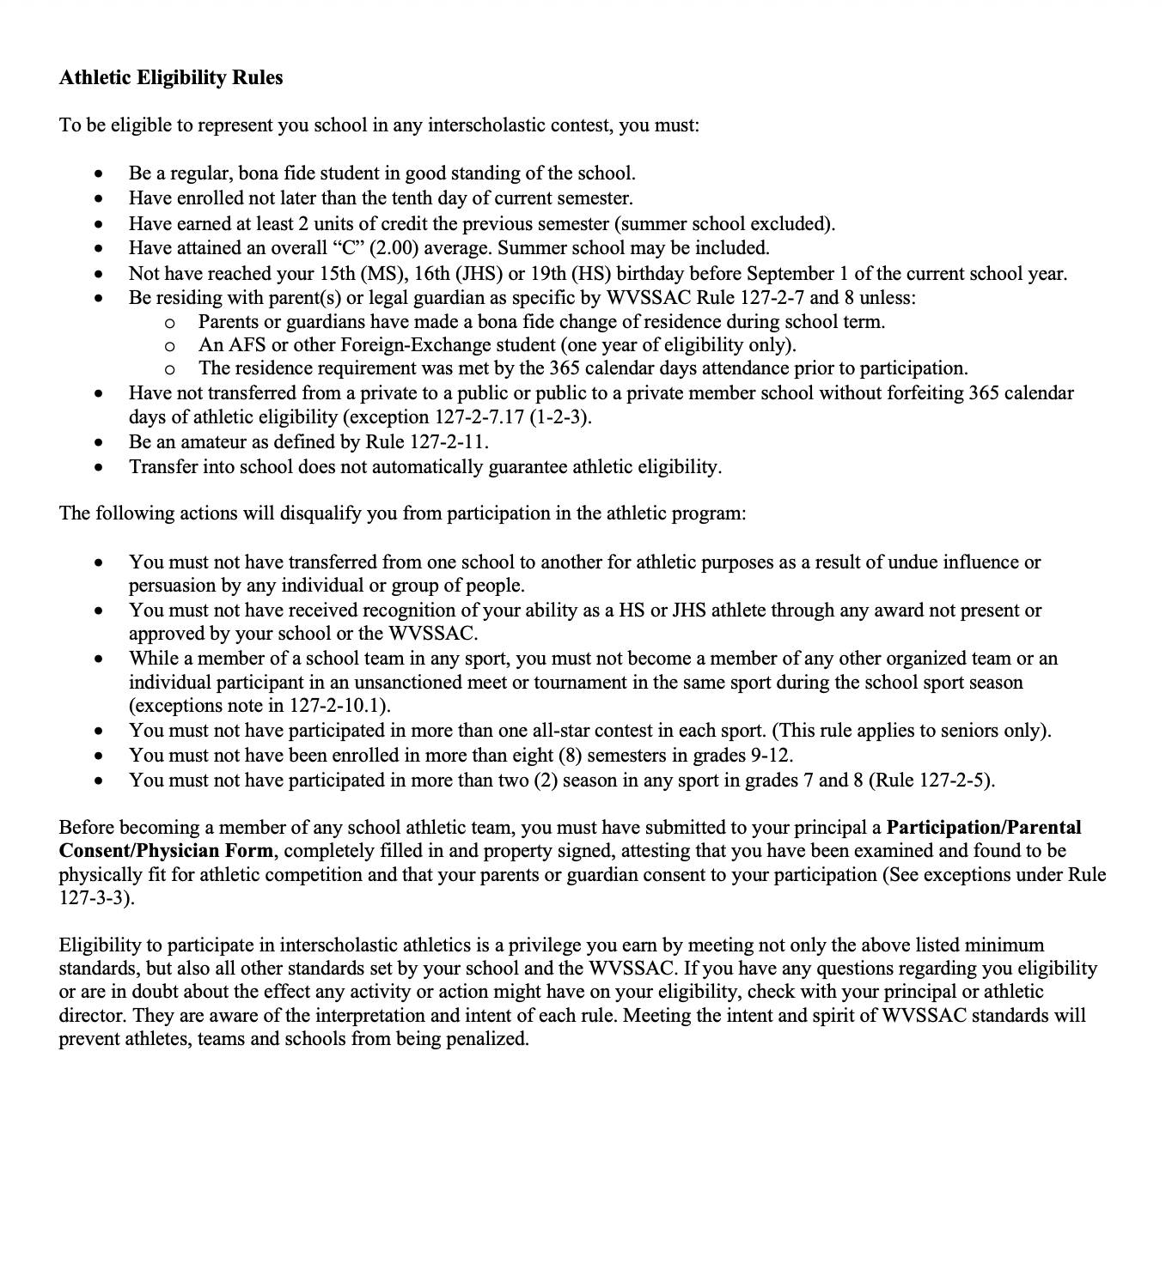

Parent & Student Rights

Parental Grievance Forms

Our goal is to create an environment where all parents and students feel heard and valued. We strongly encourage parents to reach out to the school with any concerns so that we can work toward a prompt and positive resolution. If a solution cannot be reached and a parent wishes to file a formal complaint, parental grievance forms are available on the Raleigh County Schools website.

Access to Educational Records

Transcripts
For educational records for current students, contact the guidance counselor at the school. For the permanent record of a graduate, contact the Raleigh County Board of Education. For students transferring schools, the receiving school requests the student’s records from the previous school.

Notice to Parents and Eligible Students of Rights Concerning Educational Records
Family Educational Rights and Privacy Act (FERPA)

The Family Educational Rights and Privacy Act (20 U.S.C.§ 1232g; 34CFR Part 99) is a Federal law that protects the privacy of student education records. The law applies to all schools that receive funds under an applicable program of the U.S. Department of Education.

FERPA give parents certain rights with respect to their children’s education records. These rights transfer to the student when he/she reaches the age of 18 or attends a school beyond the high school level. Students to whom the rights have transferred are “eligible students.”

Parents or eligible students have the right to inspect and review the student’s education records maintained by the school. Schools are not required to provide copies of records unless, for reasons such as great distance, it is impossible for parents or eligible students to review the records. Schools may charge a fee for copies.

Parents or eligible students have the right to request that a school correct records which they believe to be inaccurate or misleading. If the school decides not to amend the record, the parent or eligible student then has the right to a formal hearing. After the hearing, if the school sti8ll decides not to amend the record, the parent or eligible student has the right to place a statement with the record setting forth his or her view about the contested information.

Generally, schools must have written permission from the parent or eligible student in order to release any information from a student’s education record. However, FERPA allows schools to disclose those records, without consent, to the following parties or under the following conditions (34 CFR § 99.31):

- School officials with legitimate educational interest; § Other schools to which a student is transferring;
- Specified officials for audit or evaluation purposes; § Appropriate parties in connection with financial aid to a student;
- Organizations conducting certain studies for or on behalf of the school; § Accrediting organizations;
- To comply with a judicial order or lawfully issued subpoena; § Appropriate officials in cases of health and safety emergencies; and
- State and local authorities, within a juvenile justice system, pursuant to specific State law.

Schools may disclose, without consent, “directory” information such as a student’s name, address, telephone number, date and place of birth, honors and awards, and dates of attendance. However, school must tell parents and eligible students about directory information and allow parents and eligible students a reasonable amount of time to request that the school not disclose directory information about them. Schools must notify parents and eligible students annually of their rights under FERPA.

The actual means of notification is left to the discretion of each school. For additional information, you may call 1-800-USA-LEARN (1-800-872-5327) voice. Individuals who use TDD may use the Federal Relay Service (/about/contacts/gen/index.html#frs). Or you may contact the following address:
Family Policy Compliance Office
US Department of Education
00 Maryland Avenue, SW
Washington, DC. 20202-8520

