School Health Advisory Council
(SHAC)

Nacogdoches Independent School District

November 6, 2024
Ruby Ramon, LMSW
Lead Social Worker

Mission

The mission of the Nacogdoches Independent School
District School Health Advisory Council is to serve
as a liaison between the community and school
district in ensuring that local community values are
reflected in NISD health education programs.

School Health Advisory Council

An ongoing advisory group
Parents
Community members
School employees

SHAC comes together to support the knowledge and skills
young people need to be healthy

ensuring local community values are reflected in school health programs

strengthening the connection between health and learning

helping parents and community stakeholders reinforce the knowledge and skills children need to stay
healthy for a lifetime
helping plan school health programming, talking over health issues, and selecting
programs to recommend that speak to the Whole School, Whole Community, Whole
Child model
promoting school health
taking part in evaluation, accountability and quality control projects
making school health recommendations to the school board

WSCC Model
Whole School,
Whole Community,
Whole Child
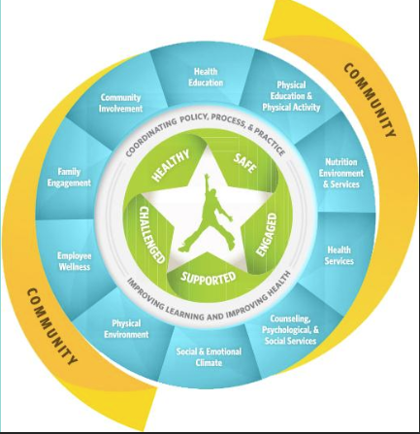

SHAC Duties include recommending
The number of hours of instruction in health education
Policies, procedures, strategies, and curriculum appropriate for specific grade levels designed to
prevent physical health concerns including -obesity, cardiovascular disease, Type 2 diabetes, and mental health concerns, including suicide through coordination of:
Health education, which must address physical health concerns and mental health concerns to ensure the integration of physical health education and mental health education;
Physical education and physical activity.
Nutrition services.
Parental involvement.
Instruction on substance abuse prevention.
School health services, including mental health services.
A comprehensive school counseling program.
A safe and healthy school environment; and
School employee wellness

SHAC Duties include recommending

Appropriate grade levels and methods of instruction for human sexuality instruction

If feasible, joint use agreements or strategies for collaboration between the
school district and community organizations or agencies

Strategies for integrating the curriculum with the following elements in a coordinated school
health program for the district:

School health services including physical health services and mental health services,
if provided at a campus by the district or by a third party under a contract with the district.

A comprehensive school counseling program.

A safe and healthy school environment.

School employee wellness.

SHAC Duties include recommending

Strategies to increase parental awareness regarding;

Risky behaviors and early warning signs of suicide risks and behavioral health
concerns including mental health disorders and substance use disorders; and

Available community programs and services that address risky behaviors, suicide
risks, and behavioral health concerns

Appropriate grade levels and curriculum for instruction regarding opioid addiction and
abuse and methods of administering an opioid antagonist

Appropriate grade levels and curriculum for instruction regarding child abuse, family
violence, dating violence, and sex trafficking, including likely warning signs that a child
may be at risk for sex trafficking

